# Project Title Health Monitoring and Logging System

Student: Shahin Haque  
 Previously known as Muhammed Azizul Haque  
 [Shahin.Haque@students.plymouth.ac.uk](mailto:Shahin.Haque@students.plymouth.ac.uk)

LinkedIn: https://www.linkedin.com/in/shahinhaque97/

Registration Number: 10479828  
Programme: MEng (Hons) Robotics  
Module Code: PROJ324

Self-proposed Project  
Supervisor:   
 Dr David Jenkins  
 Associate Professor of Nanomaterials and Devices  
 School of Engineering, Computing and Mathematics  
 Faculty of Science and Engineering  
 [D.F.Jenkins@plymouth.ac.uk](mailto:D.F.Jenkins@plymouth.ac.uk)

Aim:

For my final year project, I will be creating a health monitoring and logging device. As a student that suffers from depression and anxiety, as well as having friends and family with health-related problems. I have decided to help others in the sense of a career. Volunteering for the NHS and helping in charity events has allowed me to do so, however I want to use my knowledge of electronics to expand that to create devices that can help patients or further our goal of research to do so.

The main monitoring that is needed is from the heart, lungs, and temperature. thus, that’ll be the focus of this project.

The outline of my project is a health data logging system, Heart Rate / Sp02 / Temperature / Will be a physical device (GPS Tracking / Location Sending for Emergencies)

This project will comprise of each of my modules I have learnt at Plymouth University to showcase my skills I have learnt during my studies here.

1. From the Module ELEC240, I have learnt Microcontroller’s programming in C/C++ This will be the brain of my project, processing the incoming signals.
2. However, A microcontroller can crash, and critical data can be lost, so implementing an FPGA for the critical data storing them to an SD card could be beneficial. FPGAs taught in Module ELEC241.
3. ELEC350 is using threads to essentially have parallel processing which is critical with the different signals coming in.
4. The device will be a wearable device with GPS & GSM signals. Let’s say the subject, presses the panic button and the location id sent to the carer. An antenna will be required. An off the shelve antenna is possible, however I do know how to create my own antenna and demonstrating this skill will be something I am proud of can show to employers. Antennas have been taught in the communications module
5. As the device is battery powered, A circuit will need to be created to safely manage the device, The module ELEC237, shows how I can do this safely and efficiently without wasting energy, I have not done this module; however, the material is online for me to use as well as the support from that module leader.
6. Throughout the degree PCBs have been made for various modules and using this skill, I would like to implement a custom STM32 board specifically for this project.
7. To ensure the PCBs are mounted correctly and for the housing of the project, 3D printing will be required taught on this degree.

# Project Diagram

Charging Circuit

Data to be processed by a more power device on a network. Multiple people can access if needed. Online Archive. Etc

SD CARD Data logging

Pulse Oximeter / Impedance Pneumography

Battery

Programming Board

Custom STM32/FPGA Circuit

SIM ANTENNA

SIMCARD circuit

IOT WIFI Module

PHOTO LINK: <https://www.biopac.com/application-note/ecg-ekg-electrocardiography-12-6-3-lead/>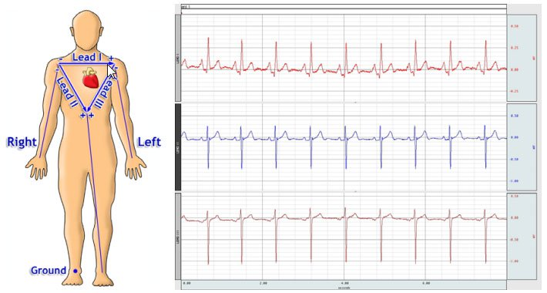

Voltage Converter Circuit

ECG circuit

# Objectives

Given that the

## 40%

## 50%

## 60%

## 70%